**DAILY ONLINE ACTIVITIES SUMMARY**

|  |  |  |  |  |  |  |  |
| --- | --- | --- | --- | --- | --- | --- | --- |
| **Date:** | **10/07/2020** | | | | **Name:** | **POOJA D S** | |
| **Sem & Sec** | **IV sem & B section** | | | | **USN:** | **4AL18CS056** | |
| **Online Test Summary** | | | | | | | |
| **Subject** | | **Object Oriented Concepts** | | | | | |
| **Max. Marks** | | **30** | | **Score** | | **-** | |
| **Certification Course Summary** | | | | | | | |
| **Course** | **Predictive Modeling and Analytics** | | | | | | |
| **Certificate Provider** | | | **Greatlearning academy** | **Duration** | | | **5.5 hours** |
| **Coding Challenges** | | | | | | | |
| **Problem Statement1:--------------------** | | | | | | | |
| **Status: ---------** | | | | | | | |
| **Uploaded the report in Github** | | | | **------------** | | | |
| **If yes Repository name** | | | | **-------------** | | | |
| **Uploaded the report in slack** | | | | **YES** | | | |

**Online Test Summary: Today 18CS45 Descriptive test was conducted there were three questions the test was from 9:30am to 10:15am.Scores not received.**

**Online Certification Summary: In today’s session I have learnt about Concepts of R-square, Goodness of Fit – R Square, Significance of variables.**

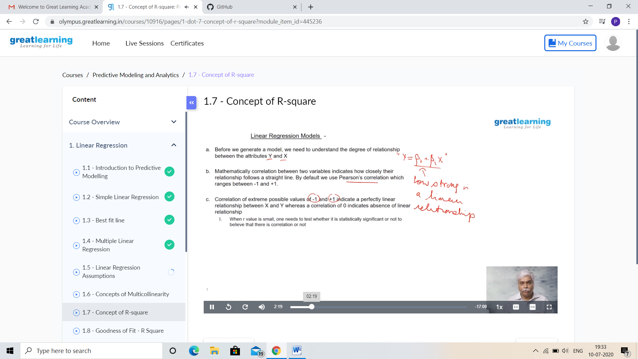

**This is the snapshot of today’s session.**

**And I participated in online “DATA ANALYTICS QUIZ” Organised by the Department of Computer Science and Engineering.**

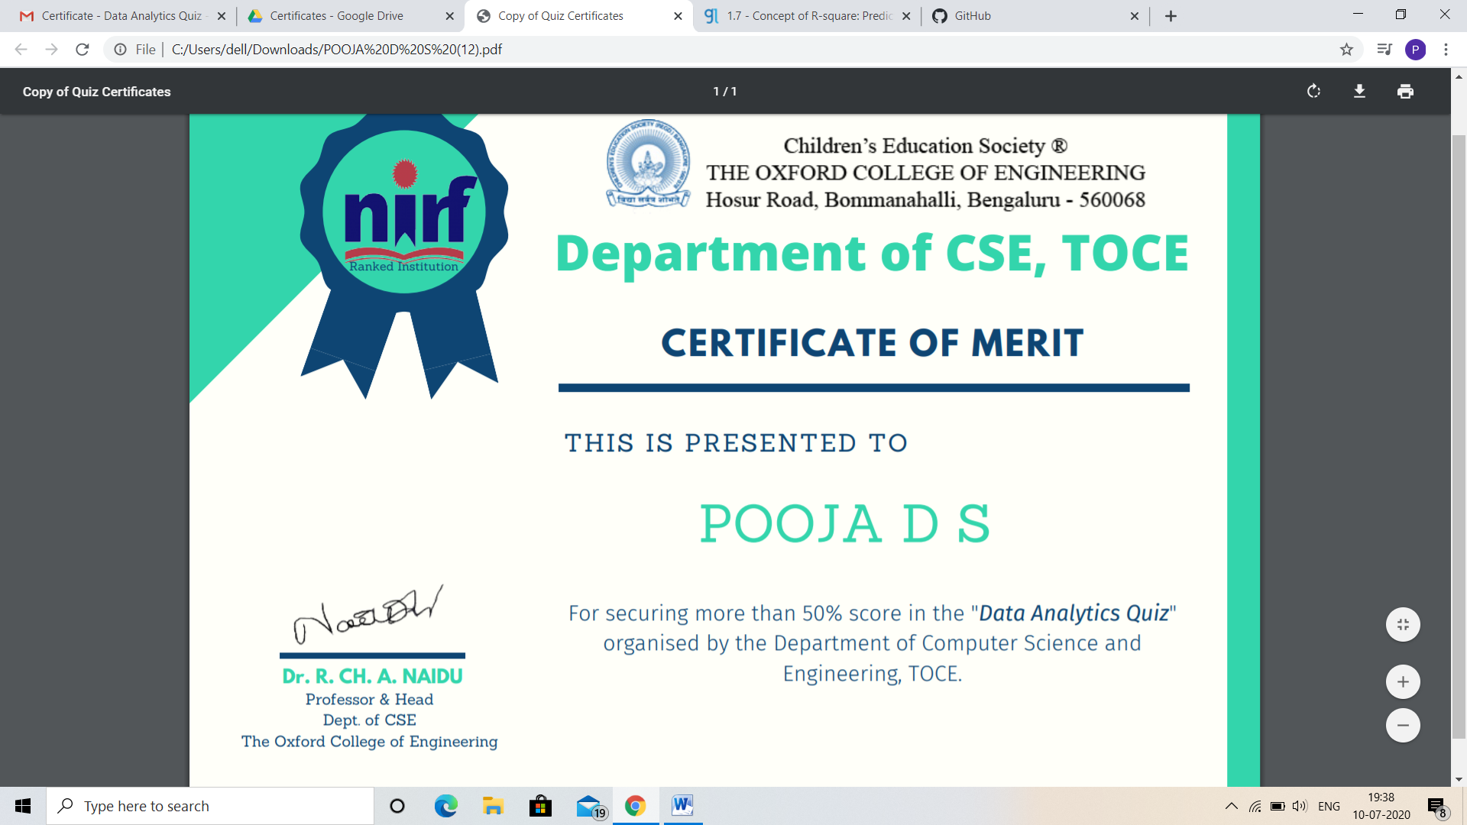

**And I participated in online “KNOWLEDGE DISCOVERY QUIZ IN COMPUTER SCIENCE” On 8th july.**

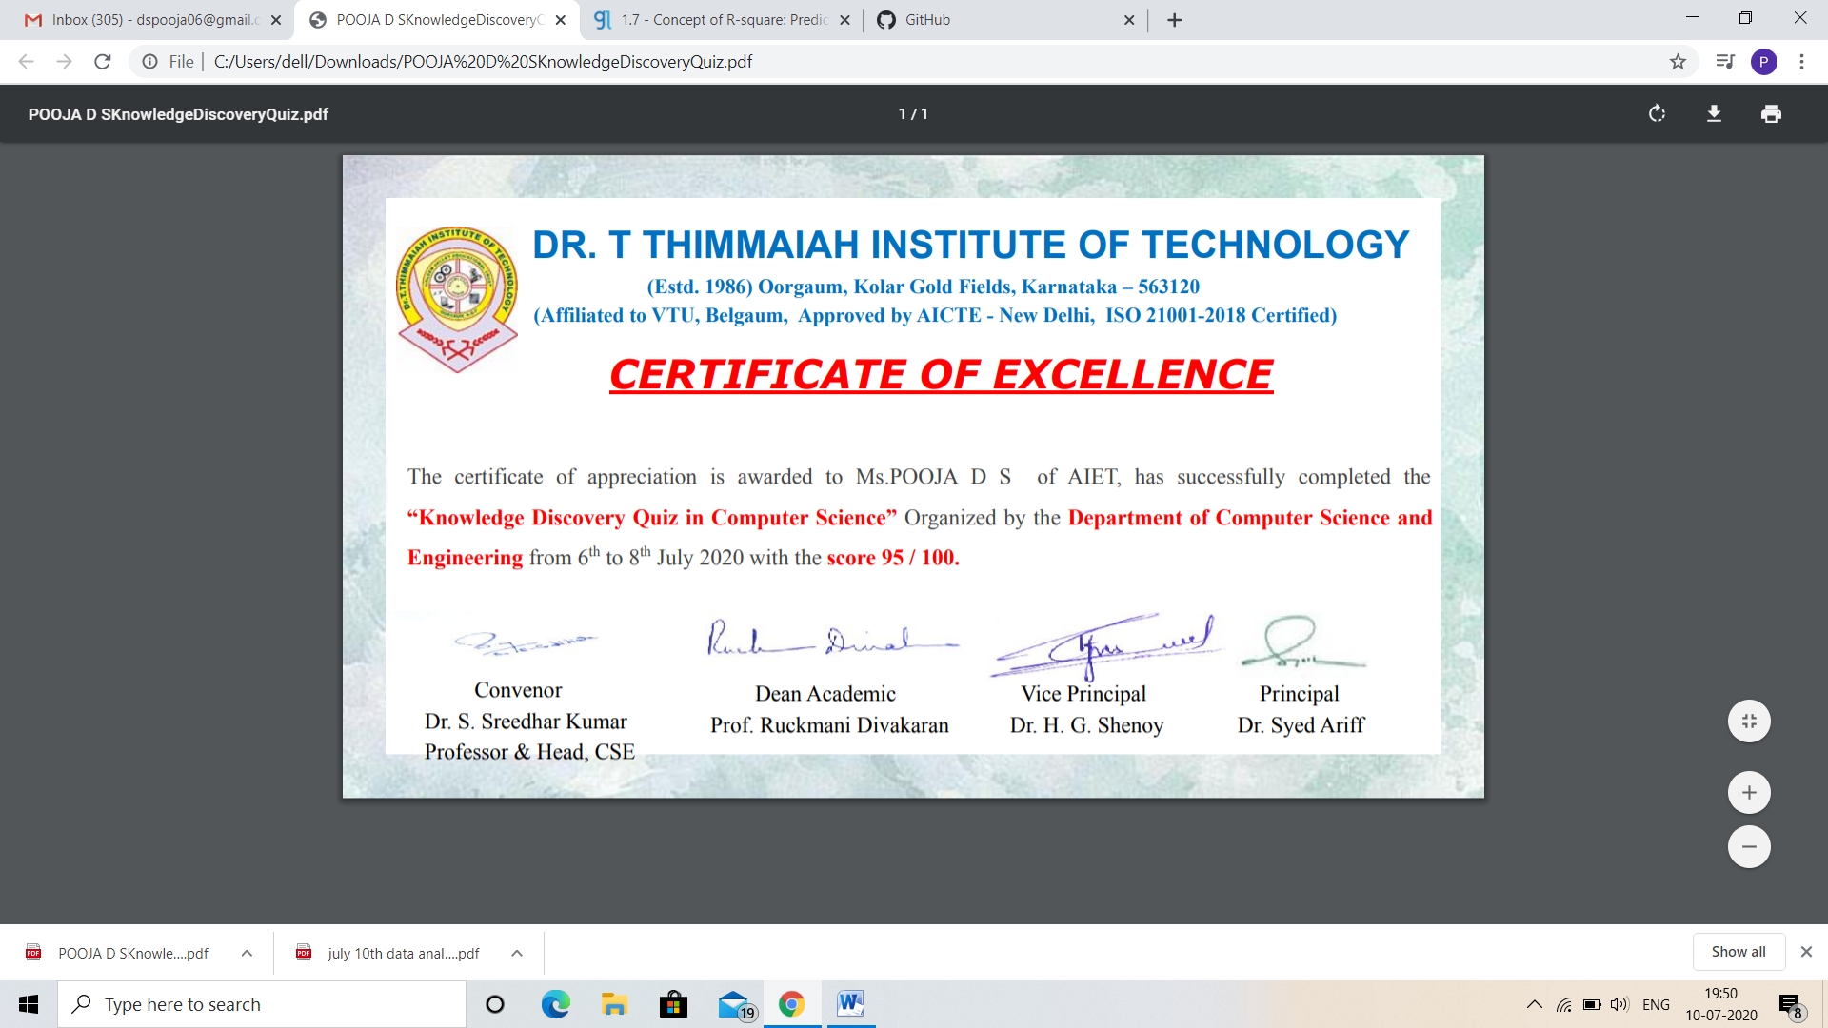

**Online Coding Summary: No problem statements were given.**